**Homework 2 Solutions**

# Problem 1

Numbers perfectly divisible by 2 are known even numbers and numbers which are not divisible by 2 are called odd numbers. This program takes an integer from user and checks whether that number is even or odd and displays the result.

**Test case**

* 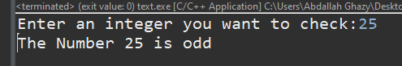**Solution**

**#include** <stdio.h>

**int** **main**() {

**int** num = 0;

**printf**("Enter an integer you want to check:");

**fflush**(stdout);

**scanf**("%d",&num);

**printf**("The Number %d is %s",num,((num%2) ? "odd" : "even"));

**return** 0;

}

# Problem 2

Alphabets a, e, i, o and u are known as vowels and all alphabets except these characters are known as consonants. This program asks user to enter a character and checks whether that character is vowel or not.

* **Solution**

**#include** <stdio.h>

**int** **main**() {

**char** character ;

**printf**("Enter an alphabet:");

**Test case**

**fflush**(stdout);

**scanf**("%c",&character);

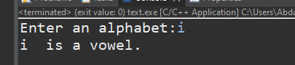

**switch**(character){

**case** 'a':

**case** 'e':

**case** 'i':

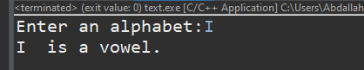 **case** 'o':

**case** 'u':

**case** 'A':

**case** 'E':

**case** 'I':

**case** 'O':

**case** 'U':

**printf**("%c is a vowel.",character);

**break**;

**default**:

**printf**("%c is a consonant.",character);

}

**return** 0;

}

# Problem 3

**C Program to Find the Largest Number Among Three Numbers**

In this program user is asked to enter three numbers and this program will find the largest number among three numbers entered by user. This program can be solved in more than one way.

* **Solution**

**#include** <stdio.h>

**int** **main**() {

**float** num1 ;

**float** num2 ;

**float** num3 ;

**printf**("Enter three numbers...\n");

**printf**("The Number 1: ");

**fflush**(stdout);

**scanf**("%f",&num1);

**printf**("The Number 2: ");

**fflush**(stdout);

**scanf**("%f",&num2);

**printf**("The Number 3: ");

**fflush**(stdout);

**scanf**("%f",&num3);

**if**(num1>num2 && num1>num3)

**printf**("Largest number = %.3f",num1);

**else** **if**(num2>num1 && num2>num3)

**printf**("Largest number = %.3f",num2);

**else**

**printf**("Largest number = %.3f",num3);

**return** 0;

}

**Test case**

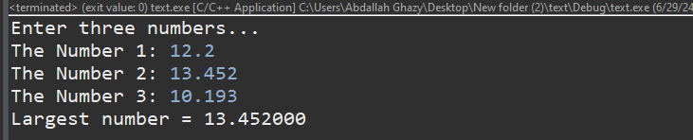

# Problem 4

**C Program to Check Whether a Number is Positive or Negative**

This program takes a number from user and checks whether that number is either positive or negative or zero.

* **Solution**

**#include** <stdio.h>

**int** **main**() {

**float** num = 0.0;

**printf**("Enter a number:");

**fflush**(stdout);

**scanf**("%f",&num);

**if**(num > 0.0)

**printf**("%.2f is positive.",num);

**else** **if**(num < 0.0)

**printf**("%.2f is negative.",num);

**else**

**printf**("You entered zero.");

**return** 0;

}

**Test case**

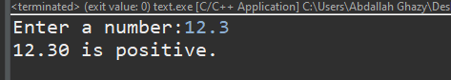

# Problem 5

**C Program to Check Whether a Character is an Alphabet or not**

This program takes a character from user and checks whether that character is an alphabet or not.

* **Solution**

**#include** <stdio.h>

**int** **main**() {

**char** Character = 0;

**printf**("Enter a character: ");

**fflush**(stdout);

**scanf**("%c", &Character);

**if** ((Character >= 'a' && Character <= 'z') || (Character >= 'A' && Character <= 'Z')) {

**printf**("%c is an alphabet\n", Character);

} **else** {

**printf**("%c is not an alphabet\n", Character);

}

**return** 0;

}

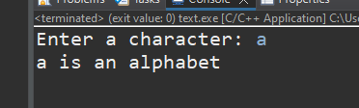

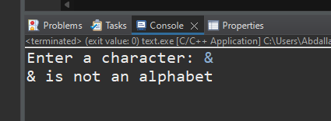

**Test case**

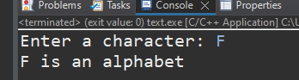

# Problem 6

**C Program to Calculate Sum of Natural Numbers**

Positive integers 1, 2, 3, 4 ... are known as natural numbers. This program takes a positive integer from user (suppose user entered n) then, this program displays the value of 1+2+3+ .... n.

* **Solution**

**#include** <stdio.h>

**int** **main**() {

**int** number = 0;

**int** sum=0;

**printf**("Enter an integer: ");

**fflush**(stdout);

**scanf**("%d", &number);

**for**(**int** i = 1 ; i <= number ; i++){

sum += i;

}

**printf**("Sum = %d",sum);

**return** 0;

}

**Test case**

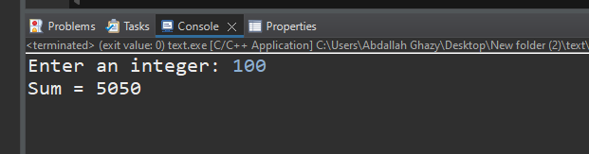

# Problem 7

**C Program to Find Factorial of a Number**

*For any positive number n, its factorial is given by:*

* factorial = 1*2*3*4 .... n
* If a number is negative, factorial does not exist and factorial of 0 is 1.

This program takes an integer from a user. If user enters negative integer, this program will display error message and if user enters non-negative integer, this program will display the factorial of that number.

* **Solution**

**#include** <stdio.h>

**int** **main**() {

**int** number = 0;

**int** factorial = 1;

**printf**("Enter an integer: ");

**fflush**(stdout);

**scanf**("%d", &number);

**if** (number > 0) {

**for**(**int** i = 1; i <= number; i++) {

factorial *= i;

}

**printf**("Factorial = %d\n", factorial);

} **else** **if** (number == 0) {

**printf**("Factorial = 1\n");

} **else** **if** (number < 0) {

**printf**("Error!!! Factorial of negative number doesn't exist.\n");

} **else** {

**printf**("Please enter a number.\n");

}

**return** 0;

}

**Test case**

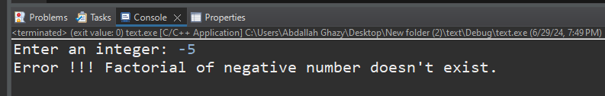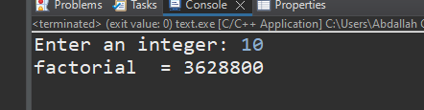

# Problem 8

**C Program to Make a Simple Calculator to Add, Subtract, Multiply or Divide Using switch ... case**

This program takes an arithmetic operator (+,-, *, /) and two operands from an user and performs the operation on those two operands depending upon the operator entered by user.

**#include** <stdio.h>

**int** **main**() {

**float** num1 = 0;

**float** num2 = 0;

**char** operator=0;

**printf**("Enter operator either + or - or * or divide :");

**fflush**(stdout);

**scanf**(" %c",&operator);

**switch**(operator){

**case** '+':

**printf**("Enter two operands \" A + B \": ");

**fflush**(stdout);

**scanf**("%f + %f",&num1,&num2);

**printf**("%f + %f = %f",num1,num2,(num1+num2));

**break**;

**case** '-':

**printf**("Enter two operands \" A - B \": ");

**fflush**(stdout);

**scanf**("%f - %f",&num1,&num2);

**printf**("%f - %f = %f",num1,num2,(num1-num2));

**break**;

**case** '*':

**printf**("Enter two operands \" A * B \": ");

**fflush**(stdout);

**scanf**("%f * %f",&num1,&num2);

**printf**("%f * %f = %f",num1,num2,(num1*num2));

**break**;

**case** '/':

**printf**("Enter two operands \" A / B \": ");

**fflush**(stdout);

**scanf**("%f / %f",&num1,&num2);

**printf**("%f / %f = %f",num1,num2,(num1/num2));

**break**;

**default**:

**printf**("Invalid operator!\n");

**break**;

}

}

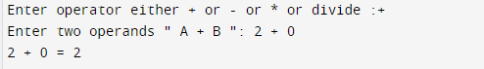

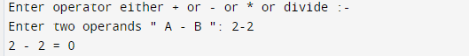

**Test case**

